Name:________________________________________________________________________________
Round up: Cause and Effect

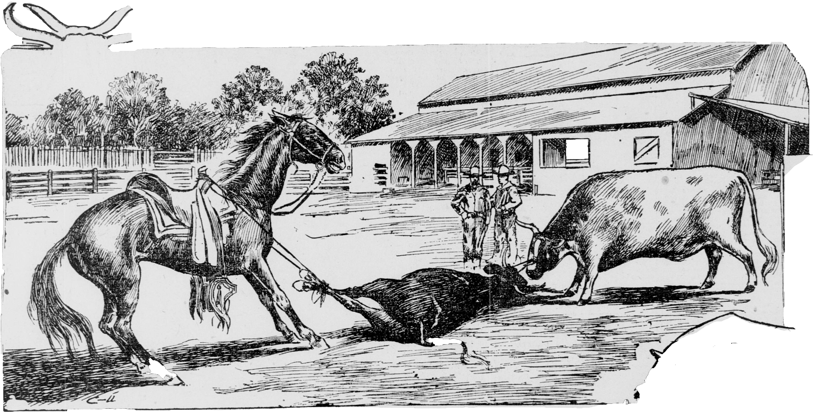

Draw a line between a cause and the effect that would most likely happen. The first one has been completed.
CAUSE EFFECT
1. Branding iron needs to be hot. Cowboy aims his six-shooter.
2. Thirsty cattle. Cowboy stays back to find it.
3. The Sun goes down. Cowboys go into town.
4. Campfire is lit. Wood is gathered for fire.
5. Rattlesnake spooks a horse. Herd rests and the campfire is lit.

6. A calf breaks away from the herd. Cattle drive begins.

7. People in the North are willing to pay Cowboys sing songs.
lots of money for beef

8. The herd arrives in Abilene, Kansas. Watering hole.

