Texas Truck Farming

- Read the advertisements out loud. What message do they convey?
A.
___________________________________________________________
___________________________________________________________
__________________________________________________________________________________________________________________________________________________________________________________________________________________________________________________________________________________________________________________________________________________________________
___________________________________________________________
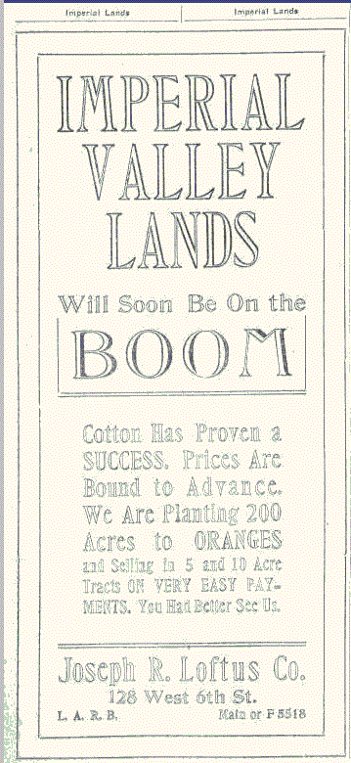
B.
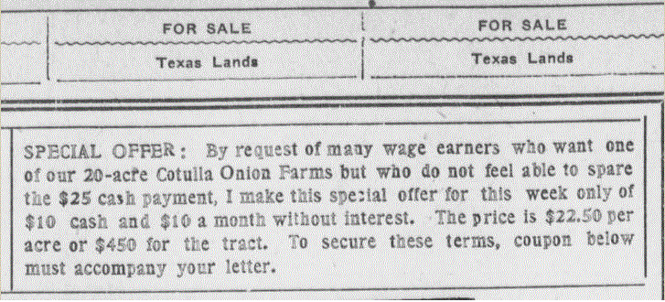

- Take a closer look at the graph on slide #3. How does Texas rank among other states in ownership of trucks? Why is this important?
________________________________________________________________________________________________________________________________________________________________________________________________________________________________________________________________________
3. Read the passage below and in your own words describe the benefit to a farmer in using a truck.

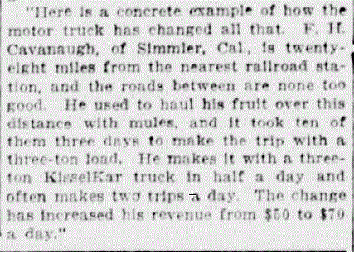

New-York tribune. (New York [N.Y.]) 1866-1924, January 19, 1913, Image 17
http://chroniclingamerica.loc.gov/lccn/sn83030214/1913-01-19/ed-1/seq-17/

________________________________________________________________________________________________________________________________________________________________________________________________________________________________________________________________________
____________________________________________________________________________________________________________________________________
- Name some of the produce that is grown in Texas. [slide #5]
_____________________ ____________________ __________________
_____________________ ____________________ __________________
_____________________ ____________________ __________________
_____________________ ____________________ __________________
- Read the article “Producer to Consumer a Boon” [Slide #4]. List the 6 advantages trucks offer when transporting goods.
________________________________________________________________________________________________________________________________________________________________________________________________________________________________________________________________________

- Describe the artesian well. Why is it important to a farm in Texas? [Slide #4]
________________________________________________________________________________________________________________________________________________________________________________________________________________________________________________________________________
____________________________________________________________________________________________________________________________________

- Read the poem below out loud or to a partner, then list all the adjectives you can find.
_____________________ ____________________ __________________
_____________________ ____________________ __________________
_____________________ ____________________ __________________
_____________________ ____________________ __________________
_____________________ ____________________ __________________

The Washington times. (Washington [D.C.]) 1902-1939, June 28, 1919, FINAL EDITION, AUTOMOTIVE SECTION, Image 22
http://chroniclingamerica.loc.gov/lccn/sn84026749/1919-06-28/ed-1/seq-22/

