The Galveston Hurricane

Fourth Grade
- From the map on slide #2 and picture on slide #4, what do you know about the location of Galveston?

__________________________________________________________________________________________________________________________________________
- In your own words, describe the hurricane and tidal wave.

(Slide #5) __________________________________________________________________________________________________________________________________________
- Who was the telegraph sent to for help? What items were urgently requested? (Slide # 6)

__________________________________________________________________________________________________________________________________________
- What were some of the hazards the residents of the city faced? (Slide #7) __________________________________________________________________________________________________________________________________________

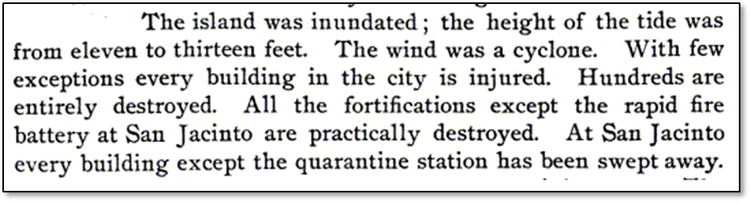

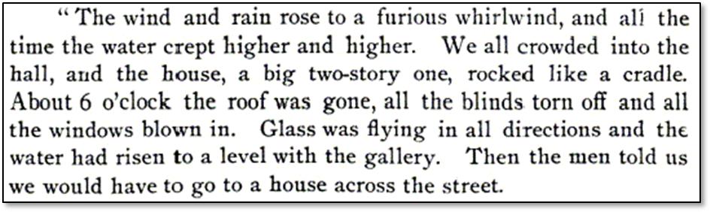
- List the appropriate adjective that goes with each noun below:

Tide ________________
Wind ________________
Building ________________
Station ________________
Water ________________
Glass ________________
House ________________
Roof ________________
- Use the words to create your own sentences to describe the hurricane.
______________________________________________________________________________________________________________
_______________________________________________________

