The Panama Canal

Crossword Puzzle
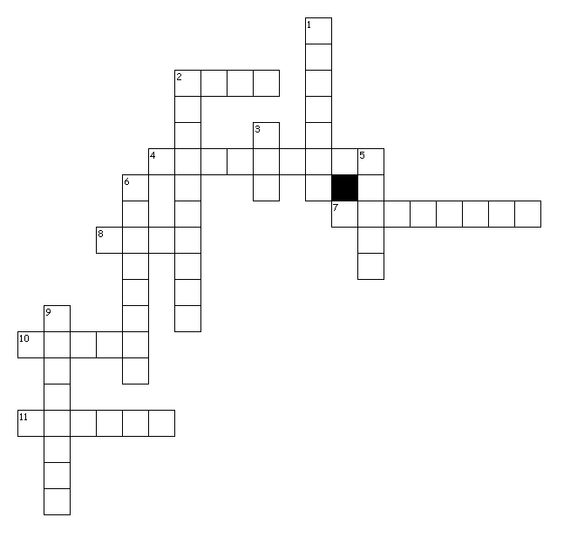
Terms:
ABANDON BREEDING TOW
CRUISE DRAIN FEAT
LOCK LOCOMOTIVE POISONOUS
PROGRESS SWAMP TAKEOVER

Clues

Across
2. part of canal where the water level changes
4. cause death or injury
7. assume control over
8. a skill
10. to let water flow out
11. travel by sea

Down
1. go away from
2. an engine used for pulling
3. pull
5. soft, wet land
6. reproducing, make more
9. move forward, improvement

