The Suffragettes
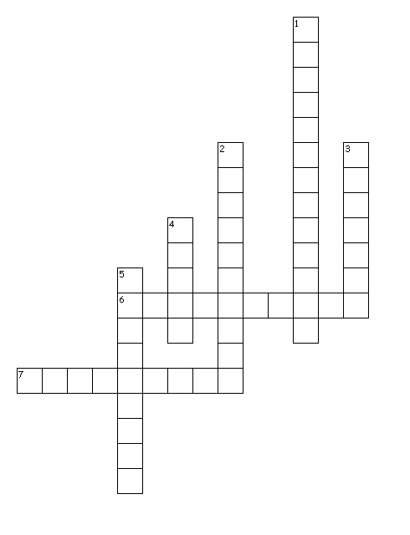
Across
6. to make a change
7. right to vote
Down
1.
2. manner or disposition
3. conviction
4. to express opinion
5. and principles

