America noviter delineata.

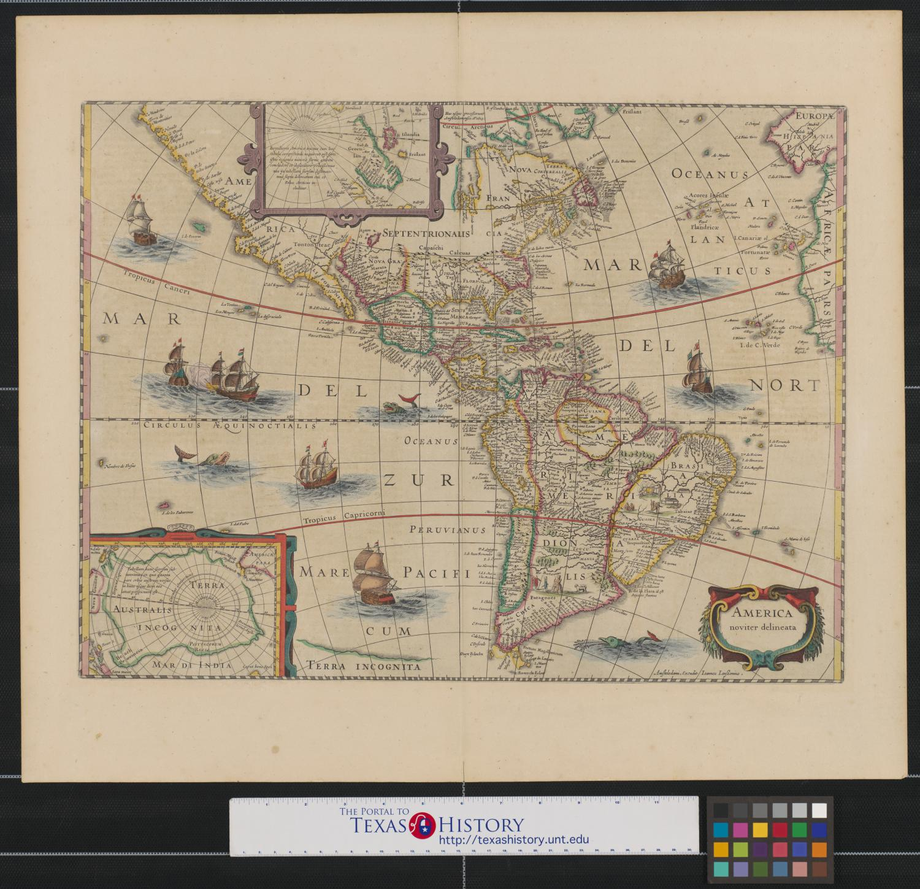

Jansson, Jan, 1588-1664. America noviter delineata., map, 1613; Amsterdam. (https://texashistory.unt.edu/ark:/67531/metapth231453), University of North Texas Libraries, The Portal to Texas History, https://texashistory.unt.edu; crediting University of Texas at Arlington Library.

Step 1: Examine the map for 10 seconds. How would you describe the map?

Step 2: Divide the photograph into quadrants and study each section individually. What do you notice?

Step 3: What place names do you recognize? Can you find Texas?

Step 4: What questions do you have about the map? How might you find answers to these questions?

