Read the passage aloud:
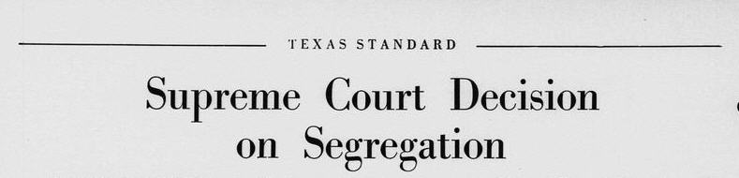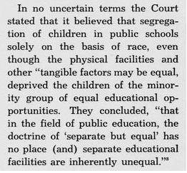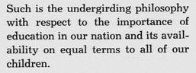

- Using the words from the box below, find and highlight them in the passage above. Then use a dictionary to define each word to create a sentence for each.

Education Minority Tangible factors

Separate but equal inherently unequal

Segregation Doctrine no place race

Word Sentence
a._______________ __________________________________
b._______________ __________________________________
c._______________ __________________________________
d._______________ __________________________________
e._______________ __________________________________
f._______________ __________________________________
g._______________ __________________________________
h._______________ __________________________________
i._______________ __________________________________

- Write a brief statement about what you think the passage means and why is it important.
_______________________________________________________________________________________________________________________________________________________________________________________________________________________________________________________________________________________________________________________________________________
- In the word cloud, write one to two terms that you think best represents the meaning of the passage above.

- Using the link below, read the passage aloud.
http://texashistory.unt.edu/ark:/67531/metapth150609/m1/1/zoom/
What steps did schools take to implement and comply with Title VI of the Civil Rights Act of 1964 for the upcoming school year? Name and record a few of them below.
________________________________________________________________
________________________________________________________________
________________________________________________________________
________________________________________________________________
________________________________________________________________
________________________________________________________________
- Name the group that rallied to support Civil Rights in Texas.
__________________________________________________________________________________________________________________________

