Click the link below to read about the literacy test.

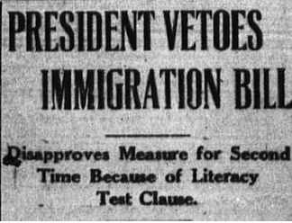
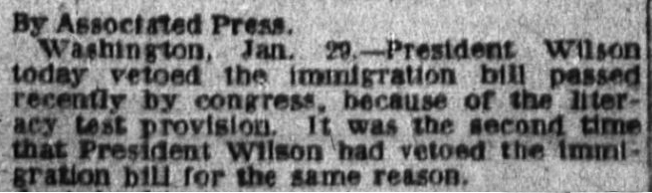
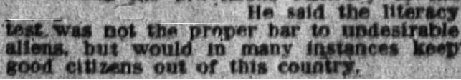

Link: http://texashistory.unt.edu/ark:/67531/metapth198631/m1/2/
1. Use the internet and an online dictionary to research the term “literacy test”
and what it means. In your own words, explain what you think it represents.
_________________________________________________________________________________________________________________________________________________________________________________________________________
2. Check one of the boxes below with an “X” to indicate your support of the poll
tax. Give a reason for your choice.
Repeal
Not to Repeal

______________________________________________________________________________________________________________________________________
Use the links below to view each document.
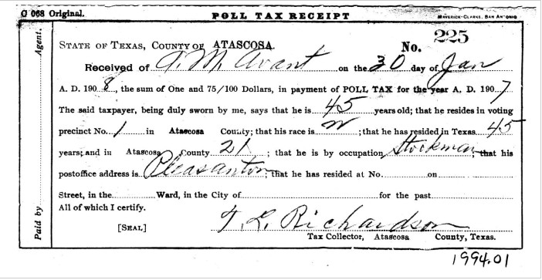
Link: http://texashistory.unt.edu/ark:/67531/metapth88185/m1/1/
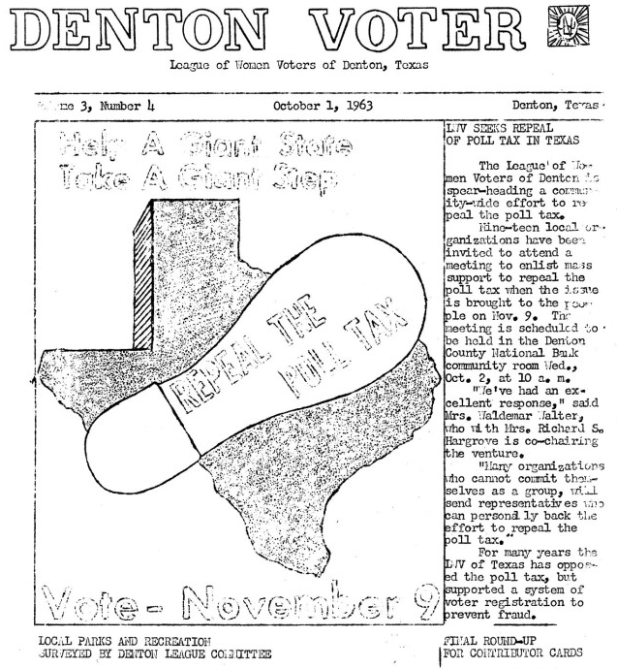
Link: http://texashistory.unt.edu/ark:/67531/metapth90937/m1/1/

3. In your own words, describe the term “poll tax” and the word “repeal”. Use
your textbook or an online source for help.
_________________________________________________________________________________________________________________________________________________________________________________________________________
Take a closer look at the poll tax receipt. Use the link below or click on the image from the lesson page.
Link: http://texashistory.unt.edu/ark:/67531/metapth88185/m1/1/
4. What information is recorded? List the information below. Give a title before
each. (the first two are given)
N_ : _______No______________ R_ _ _ _ _ _ _ _ _: _Received of__

D_ _ _ ______________________ A _ _ _______________________

R _ _ _ ____________________ C _ _ _ _ _ __________________

R _ _ _ _ _ _ ____________ O _ _ _ _ _ _ _ _ _ __________________

T _ _ C _ _ _ _ _ _ _ _ _______________________________________

5. Look up the meaning of the terms below, then define each term. You may use
your textbook or an online source.

Grandfather clause: _________________________________________
Enfranchisement: _________________________________________
Suffrage: _________________________________________
Separate but equal: _________________________________________
Right to vote: _________________________________________
Democracy: _________________________________________
Education: _________________________________________

6. Should voters have to register to vote? Why or why not?

_______________________________________________________________________________

_______________________________________________________________________________

_______________________________________________________________________________

7. Solve the puzzle

Right to Vote
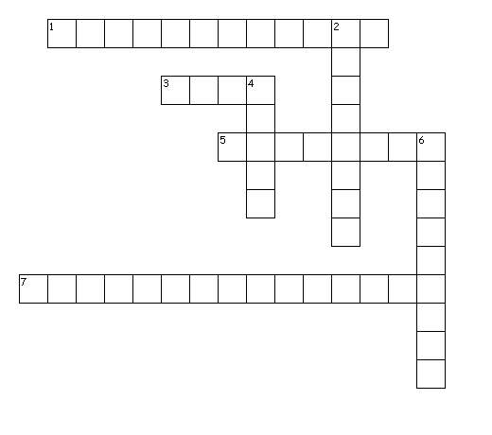
Across
1. a type of voter registration
3. to express choice
5. the right to vote
7. to endow with right of citizenship

Down
2. to keep apart
4. to be the same
6. to acquire knowledge

