Advanced Worksheet
A batting average tells us how good a player is at the plate. It compares the number of hits a player has to the number of chances he had. For example: 50 hits / 250 is .200 which is 20% or 2 hits out of every 10 at bats.
View the newspaper article, then compare the batting average of any two players from the table. List the batting average for the two teams.
______________________________________________________________________________________________________
______________________________________________________________________________________________________
______________________________________________________________________________________________________
______________________________________________________________________________
______________________________________________________________________________

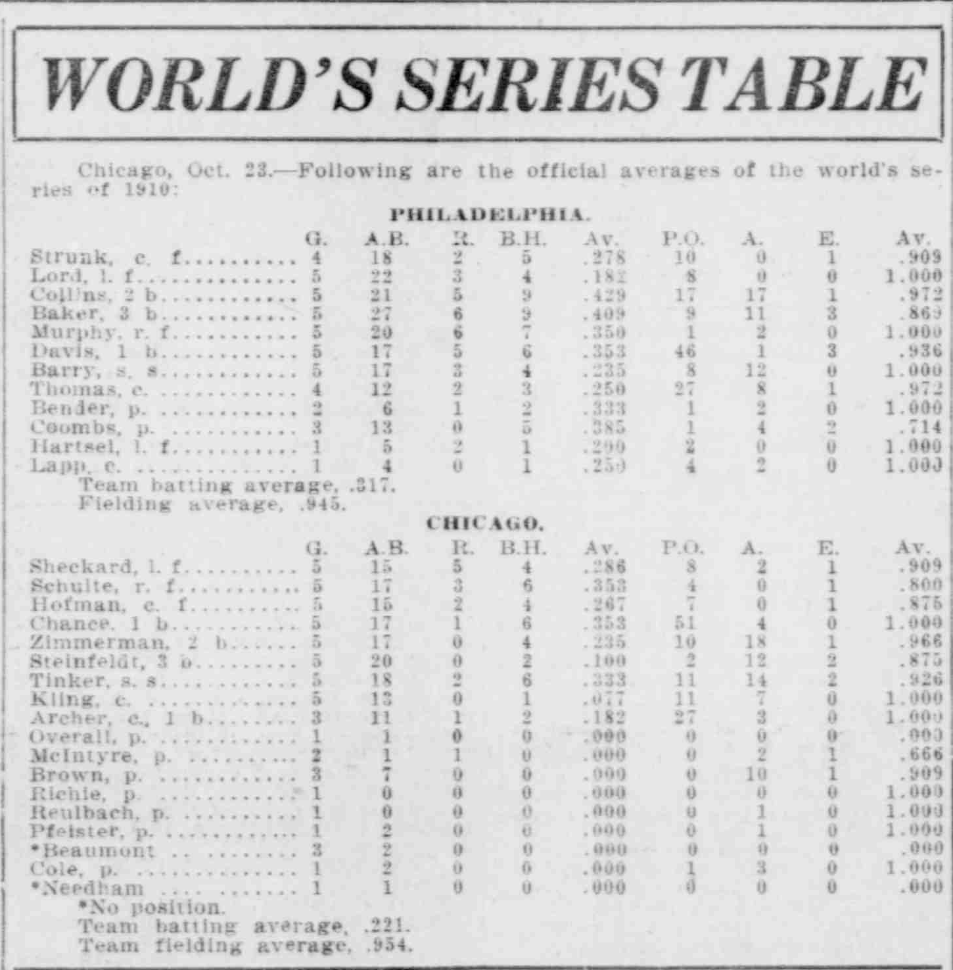
The Salt Lake Herald-Republican, October 24, 1920
http://chroniclingamerica.loc.gov/lccn/sn85058140/1910-10-24/ed-1/seq-7/

- What do you think happened in the picture?
______________________________________________________________________________________________ ______________________________________________________________________________________________
______________________________________________________________________________________________
______________________________________________________________________________________________

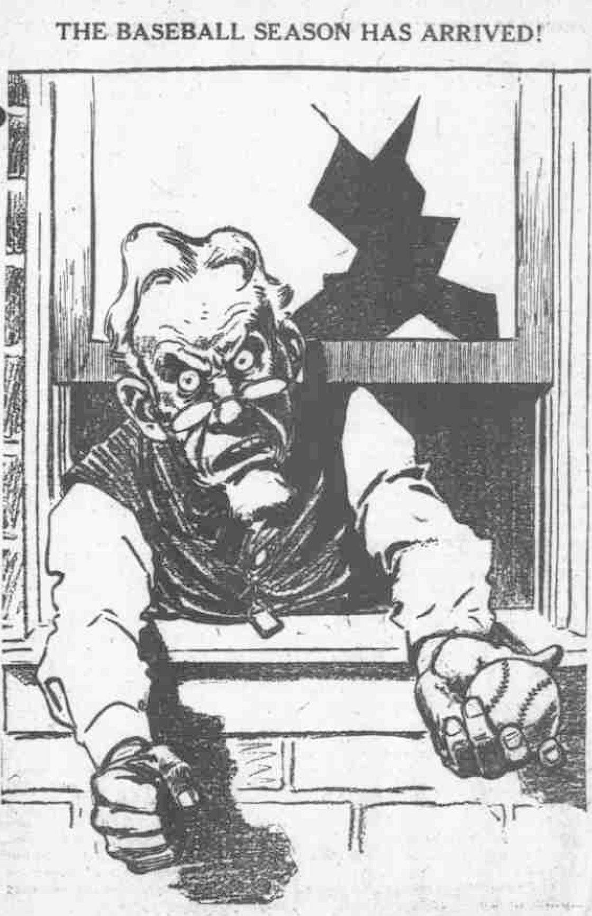
The Day Book (Chicago, Illinois), April 07, 1914
http://chroniclingamerica.loc.gov/lccn/sn83045487/1914-04-07/ed-2/seq-31/

2. List five adjectives to describe his response. Use them to create sentences to describe the event.

a. ______________________ b. ______________________ c. _______________________
d. ______________________ e. ______________________

- __________________________________________________________________________
- __________________________________________________________________________
- __________________________________________________________________________
- ___________________________________________________________________________
- ___________________________________________________________________________________________________________________
4. Use the link to view the newspaper article to answer the following questions. (Use a separate sheet of paper to record your responses.)
a. Name the two leagues
b. View the table and list three facts about Manager: Jennings’ team
c. View the table and list three facts about Manager: Chances’ team
d. List the batting average for both teams

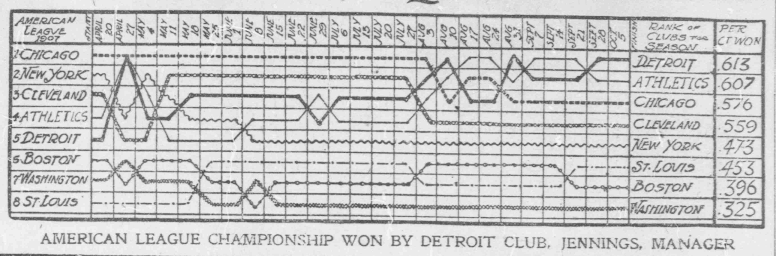

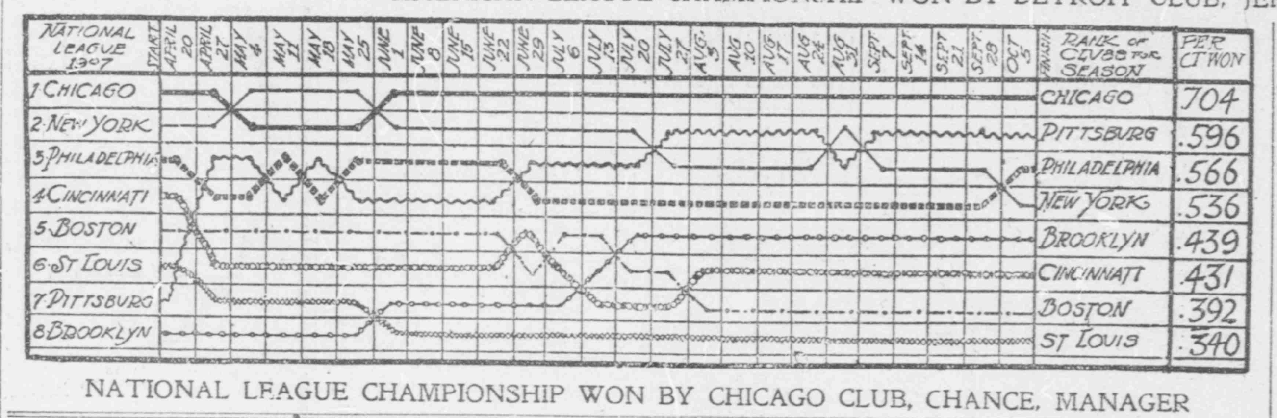
The Washington Times, October 08, 1907
http://chroniclingamerica.loc.gov/lccn/sn84026749/1907-10-08/ed-1/seq-10/

5. Do a self-portrait by drawing your own features for the face. Give your baseball player a name and then color it.
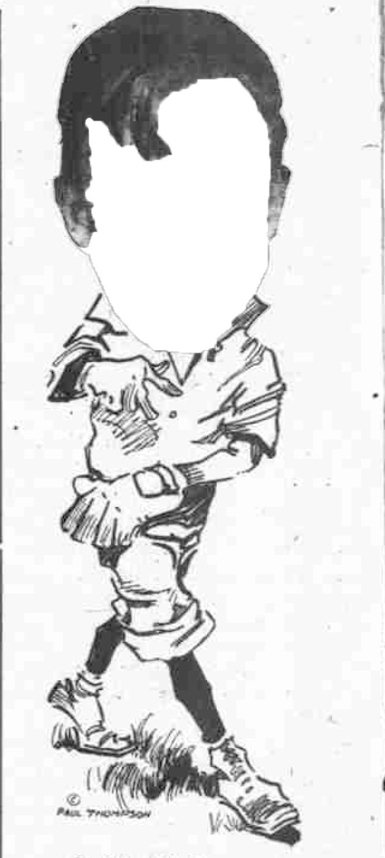
The Day Book (Chicago, Illinois) February 10, 1912
http://chroniclingamerica.loc.gov/lccn/sn83045487/1912-02-10/ed-1/seq-4/
Name: ______________________________________________

