Baseball:
Beginners Worksheet
View the pictures below and number each player’s action according to the order it would occur during a baseball game.

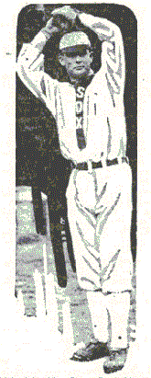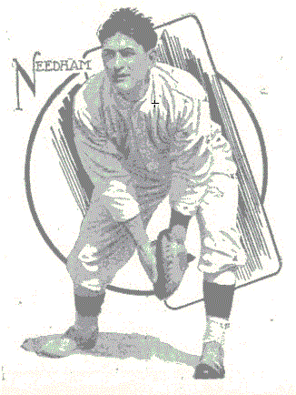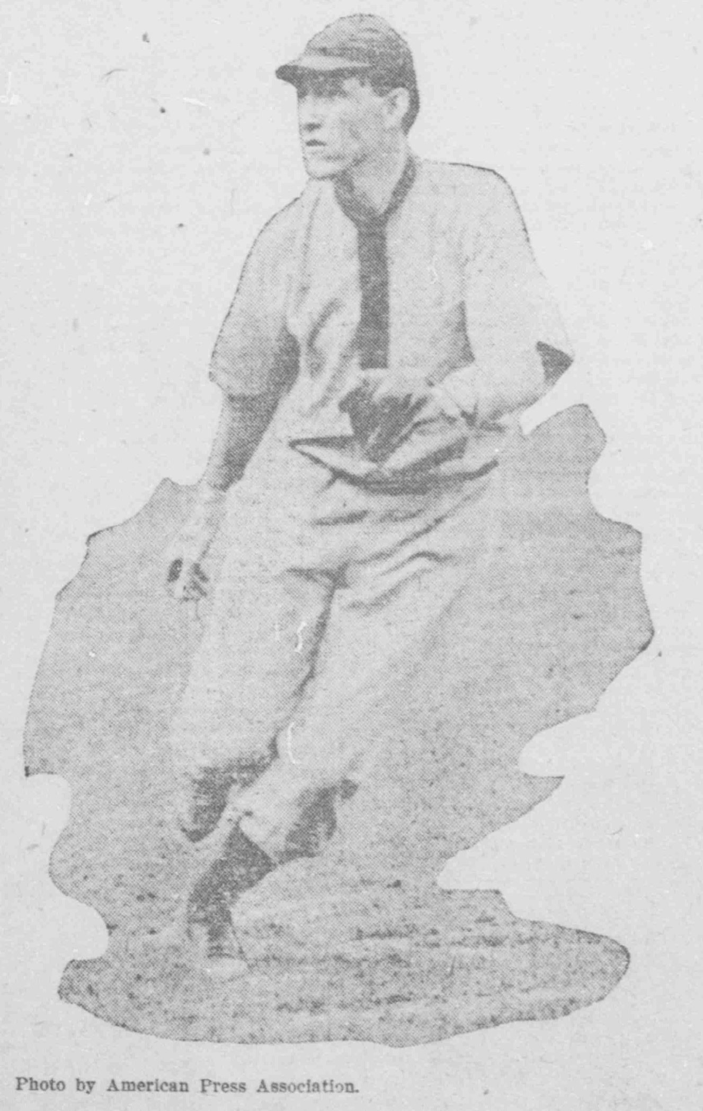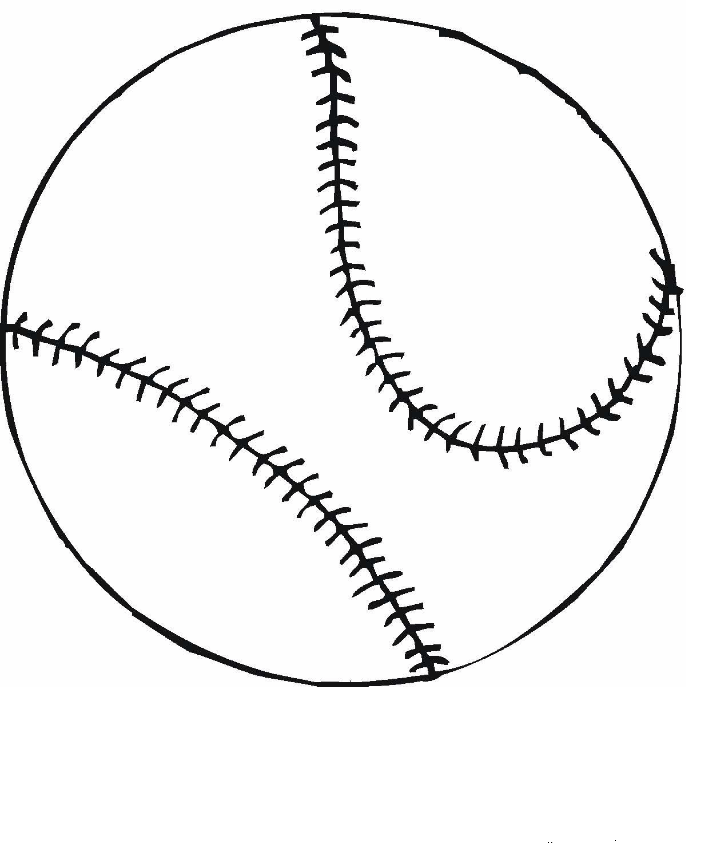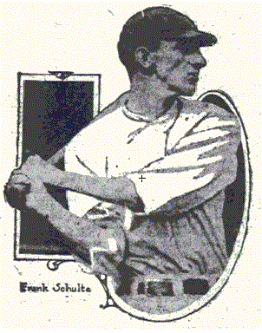

- A baseball field is also called a __ __ __ __ __ __ __ __.

- What shape is a baseball field similar to? __________________________

- What 3 items must you have to play baseball?
__ __ __ __ __ __ __ __ __ __ __ __

- Read the information in the tables. What are the names of the two teams?
___________________________________________________________________________________________________________________________________________________________________________________________________________________________________________________

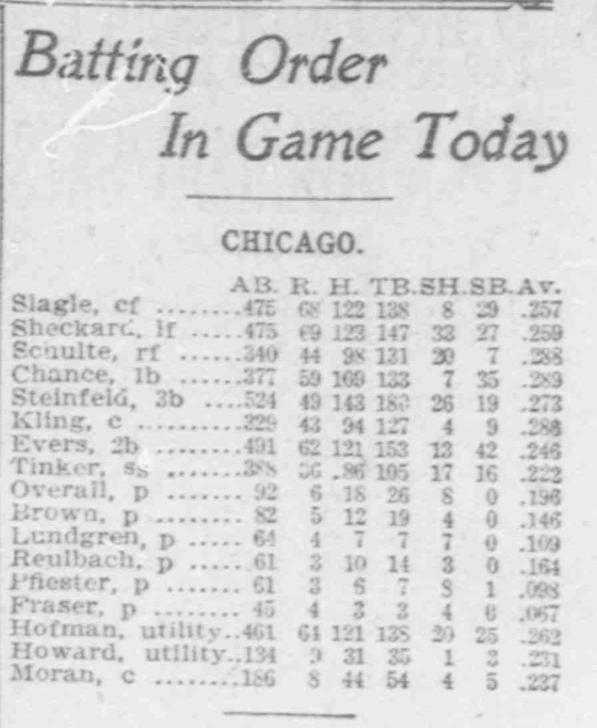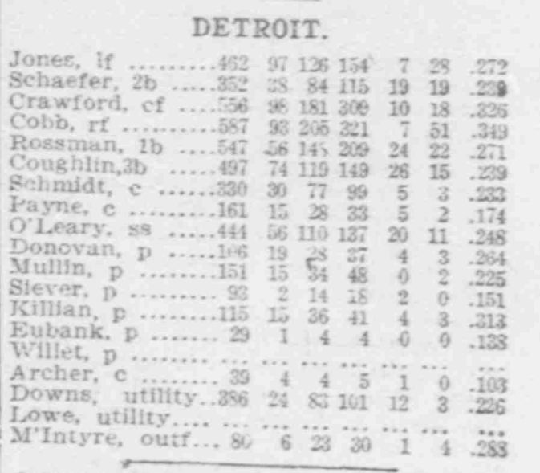
The Washington Times, October 08, 1907
http://chroniclingamerica.loc.gov/lccn/sn84026749/1907-10-08/ed-1/seq-10/

- Choose one player from each team and list their batting average. (the average is in the far left column, i.e. 233)
_______________________________________________________________________________________________________________________________________________________________________________________________________________________________________________________________
7. Do a self-portrait by drawing your own features for the face. Name your baseball player, then color in all the parts.
Name: ____________________________________

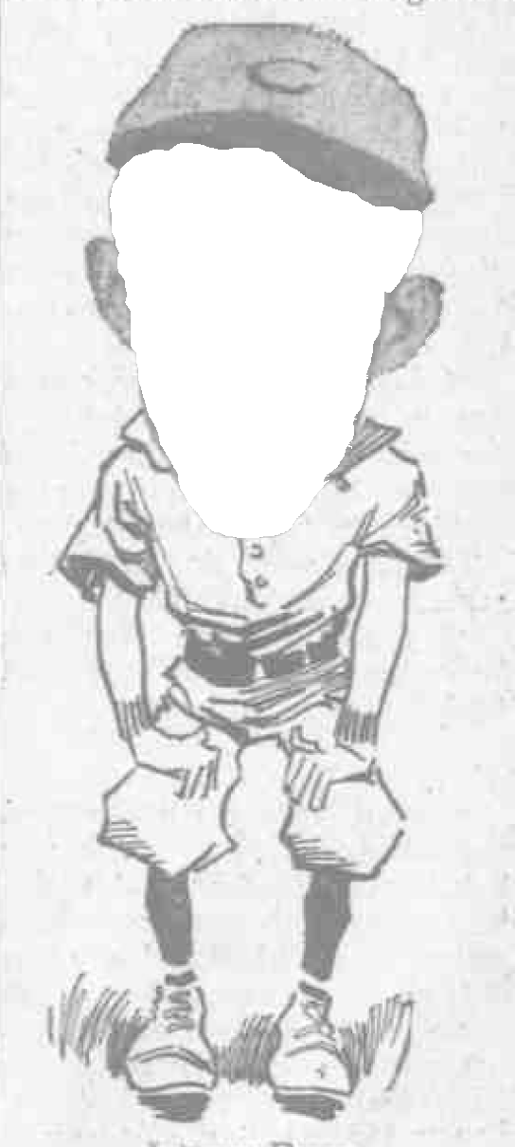
The Day Book, October 22, 1912
http://chroniclingamerica.loc.gov/lccn/sn83045487/1912-10-22/ed-1/seq-21/

