Advanced Worksheet
- Read the passage below aloud.
List the names of places encountered and as many adjectives as you can find.
Write your own account of a hot air balloon ride on a separate sheet of paper.

______________________________________________________________________________________________________________________________________________________________________________________________________
___________________________________________________________________________________________________
___________________________________________________________________________________________________

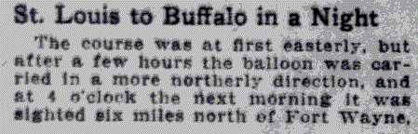
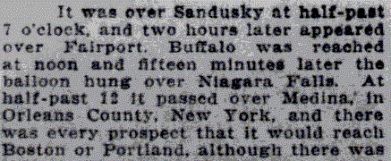
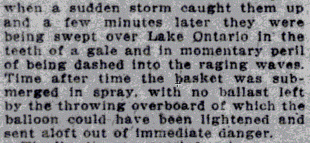
The San Francisco Call, 1895 – 1913, February 03, 1907
http://chroniclingamerica.loc.gov/lccn/sn85066387/1907-02-03/ed-1/seq-7/

_________________________
___________________________________________________________________________

2. Flying no longer a figment of imagination!
Read the article name, locate the tallest aeroplane, and list four other types of flying machines.
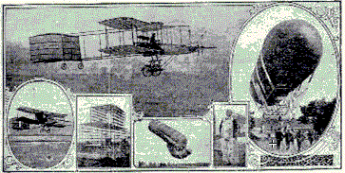
New York Tribune, July 26, 1908
http://chroniclingamerica.loc.gov/lccn/sn83030214/1908-07-26/ed-1/seq-54/

3. The invention of the airplane created the need for a whole set of new laws. Use the embedded link to read the newspaper article and list 7 laws that you see as important. Circle 2 that you think we still need.
________________________________________________________________________________________________________________________________________________________
____________________________________________________________________________________________________________________________________________________________________
________________________________________

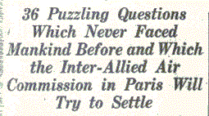
The Washington Times, February 23, 1919
http://chroniclingamerica.loc.gov/lccn/sn84026749/1919-02-23/ed-1/seq-22/

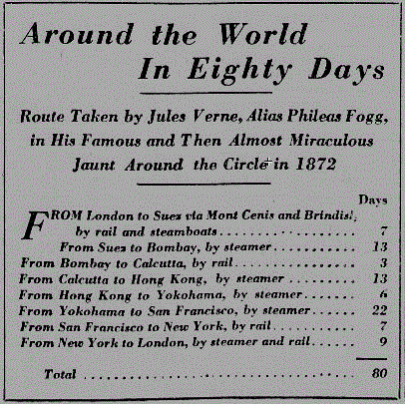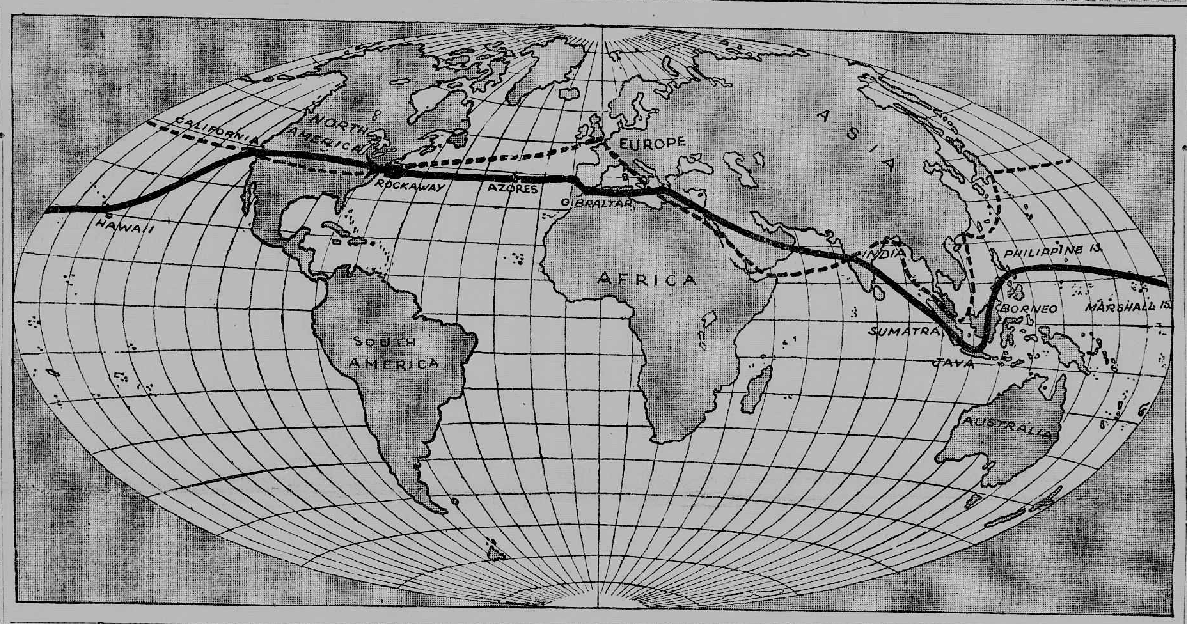
Around the world in 7 Days
National Edition, American Weekly, February 23, 1919
http://chroniclingamerica.loc.gov/lccn/sn84026749/1919-02-23/ed-1/seq-22/
New York Tribune, Ocotber 19, 1919
http://chroniclingamerica.loc.gov/lccn/sn83030214/1919-10-19/ed-1/seq-59/

4. Use the embedded links to read both articles. Then answer the questions below.
List the name of each city & country where a stop was made in the 7 day trip around the world. (follow the dotted line)
How fast is it possible to travel by air nowadays? Give an example.
__________________________________________________________________________________________________________________________________________________________________________________________________________________________________________________________________________________________________________________________________________________________________________________________________________________________________________
___________________________________________________________________________
___________________________________________________________________________
5. Read the article about the airplane “The America” and its flight across the Atlantic. Answer the following questions:
What kind of plane is the America?
What is the horsepower of its engine?
What does the author mean by “favoring wind”?
How many hours does it take to complete the trip?
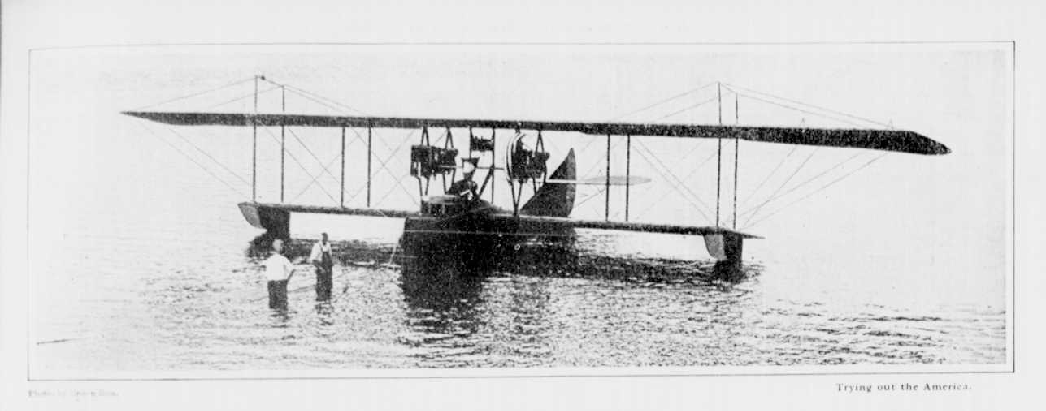
The New York Tribune, August 02, 1914
http://chroniclingamerica.loc.gov/lccn/sn83030214/1914-08-02/ed-1/seq-51/

6. Briefly describe how you think aircraft of the future will be like?
_________________________________________________________________________________________________________________________________________________________________________________________________________________________________
_________________________________________________________________________________________________________________________________________________________________________________________________________________________________

