Mapping Airmiles
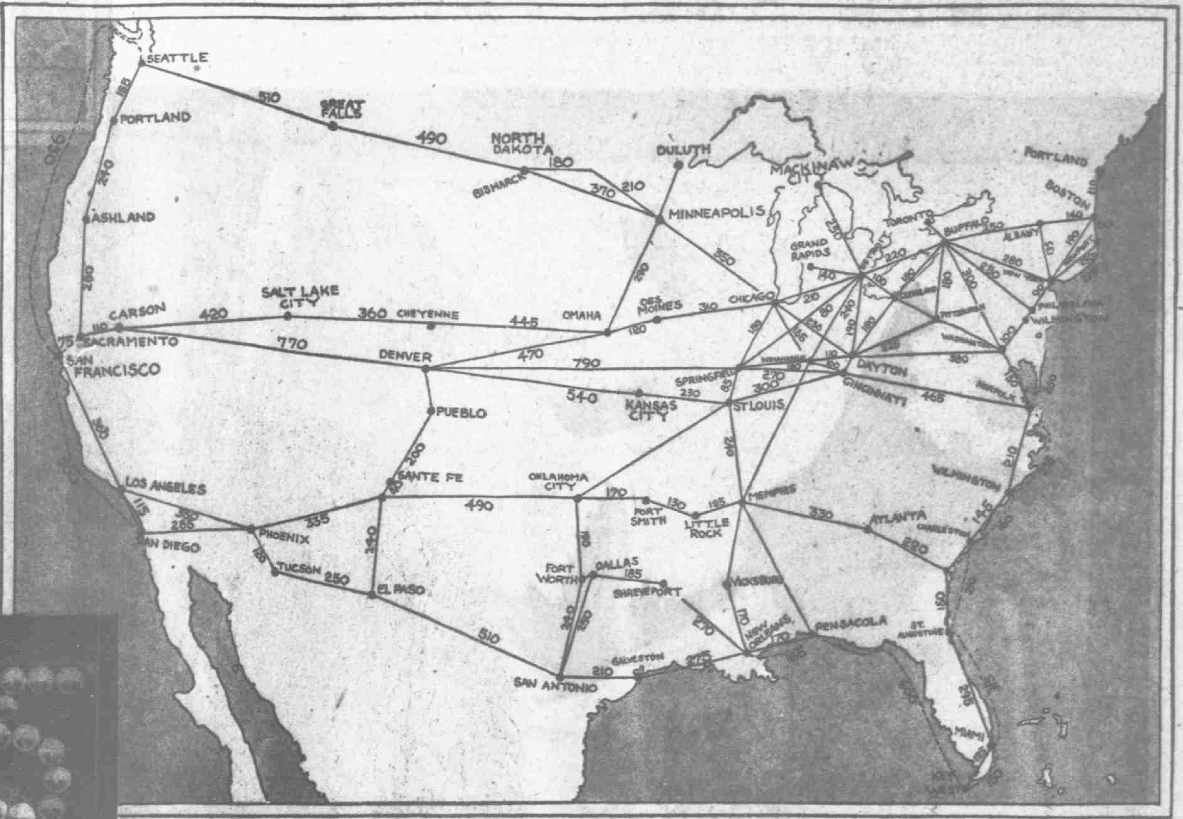
New York Tribune, 1866-1924, October 19, 1919
http://chroniclingamerica.loc.gov/lccn/sn83030214/1919-10-19/ed-1/seq-59/

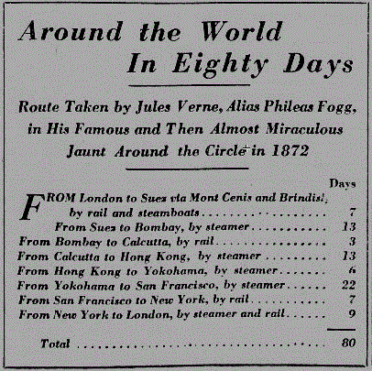
National Edition, American Weekly, February 23, 1919
http://chroniclingamerica.loc.gov/lccn/sn84026749/1919-02-23/ed-1/seq-22/

Julius Verne in 1872 went around the world in 80 days.
The Curtiss Aeroplane Experts charted their map of airmiles.
Use the embedded newspaper links to determine how many airmiles it would take to travel between the U.S. cities given below.
For each of the questions below, list the airmiles for each section and then circle your final answer.
- Sam travelled from Phoenix, Arizona to Denver, Colorado making two stops one in Sante Fe, New Mexico and the other in Pueblo. His plane traveled 70 miles an hour how many airmiles did he fly and how long did it take him?
________________________________________________________________________________________________________________________________________________________________________________________________________________________________________________________________________________________________________________________________________________________________
- Joann started her trip in El Paso, Texas through San Antonio, Fort Worth and got down in Oklahoma City, Oklahoma. If the plane traveled 70 miles an hour, how long did it take her to get to her destination? List the airmiles for each section and then circle your final answer.
________________________________________________________________________________________________________________________________________________________________________________________________________________________________________________________________________________________________________________________________________________________________________________________________________________________________________________________

- How many airmiles, how many stops, and how long would it take to fly from San Francisco, California to Boston, Massachussetts? The plane travels 70 miles an hour.
____________________________________________________________________________________________________________________________________________________________________________________________________________________________________________________________________________________________________________________________________________________________________________________________________________________________

