Teacher Guide
Cowboy Culture in Texas
Beginning
Beginning

Activity Ideas …
Discussion Starters:
Cowboy Culture
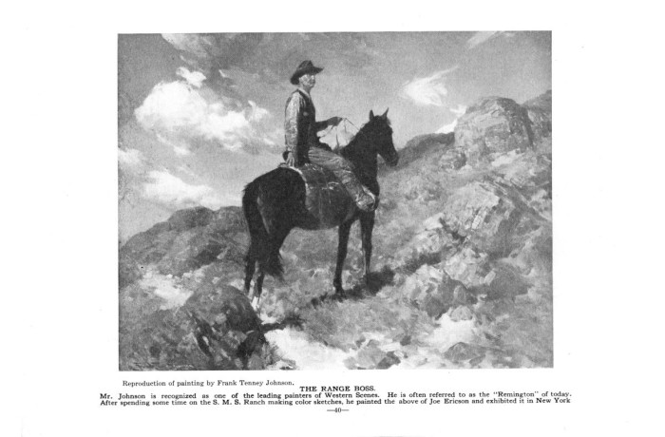
Beginning
- Have students compare two related items.
Intermediate
- Have students expand or alter textbook explanations of history based on the primary sources they study.
Advanced
- Ask students to consider how a series of primary sources support or challenge information and understanding on a particular topic.
- Have students refine or revise conclusions based on their study of each subsequent primary source.
- Discussion Starters:
- Who were the first people to introduce cattle to Texas?
- What made Texas a good environment for raising cattle?
- Discussion Starters:
- What were some of the dangers cowboys faced on the trail?
- How did cowboys entertain themselves on the trail?
http://texashistory.unt.edu/ark:/67531/metapth46819

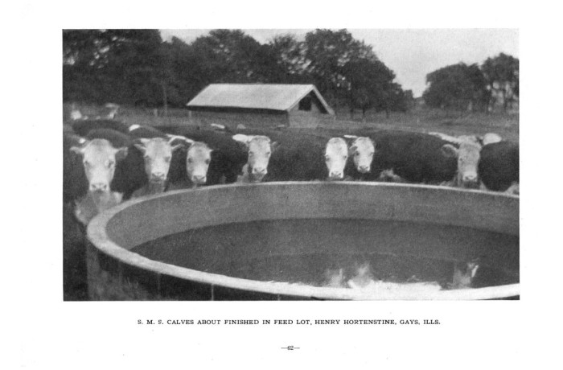
- Discussion Starters:
- Name the different cultures that contributed to the success of the cattle kingdom?
- Why was raising cattle important for Texas?

http://texashistory.unt.edu/ark:/67531/metapth46819
Library of Congress – Primary Source Analysis Tools
http://www.loc.gov/teacher

Teacher Answer Sheet:
Cattle Drive worksheet: 1. mountains, hills
2. 35 miles
3. gun shells and arrow spikes
River Crossing worksheet: 1. The cattle stampeded and ran across the river
2. Steep bank, height of the river rose, saddle slipped from the horse
Innovations on the plains worksheet: 1. Antelope
2. Windmill
3. Increased power and water supply
6. Cattle would spring back
7. Branding the cattle
8. Texas Rangers

Analyzing Primary Sources - Teacher’s Guide

Further Investigation
Help students to identify questions appropriate for further investigation, and to develop a research strategy for finding answers.
What more do you want to know, and can you find out?
OBSERVE

QUESTION

REFLECT

Have students identify and note details.
What do you notice first?
Find something small but interesting.
What do you notice that you didn’t expect?
What do you notice that can’t explain?
What do you notice now that you didn’t earlier?
Have students ask questions to lead to more observations and reflections.
What do you wonder about …
Who?
What?
When?
Where?
Why?
How?
Encourage students to generate and test hypotheses about the source.
What do you think was happening when this occurred?
What was used to create this?
Why do you think this is important?
If this took place today, what would be different?

